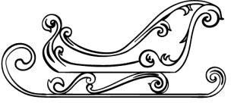
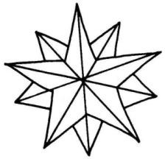
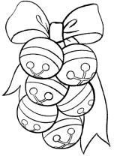
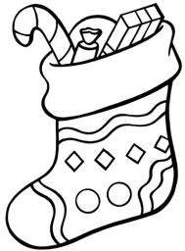

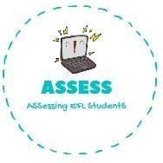
ENGLISH EXAM

Writing

Name: Surname: N^{ber}: Grade/Class:
Assessment: | Date:
 | Teacher’s signature:  _ | Parent’s signature:

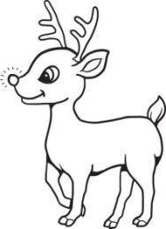
1. Order the words and paint these Christmas drawings!

e-r-n-r-d-e-e-i
l-i-h-g-s-e
t-a-s-r
l-b-a-l-s
t-s-c-i-g-n-o-k

Assessing EFL Students

