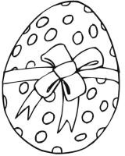
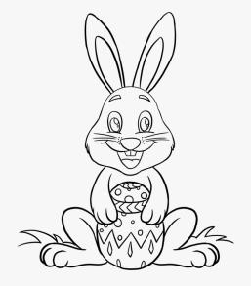
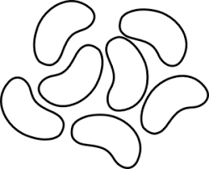
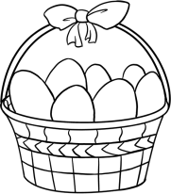

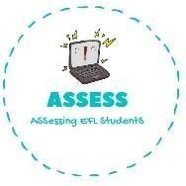
ENGLISH EXAM

Writing

Name: Surname: N^{ber}: Grade/Class:
Assessment: | Date:
 | Teacher’s signature:  _ | Parent’s signature:

1. Order the words and paint these Easter drawings!

a-e-s-e-r-t u-h-t-n
a-e-s-e-r-t g-g-e-
a-e-s-e-r-t n-n-b-u-y
e-j-y-l-l e-a-b-s-n
a-s-b-t-e-k

Assessing EFL Students

