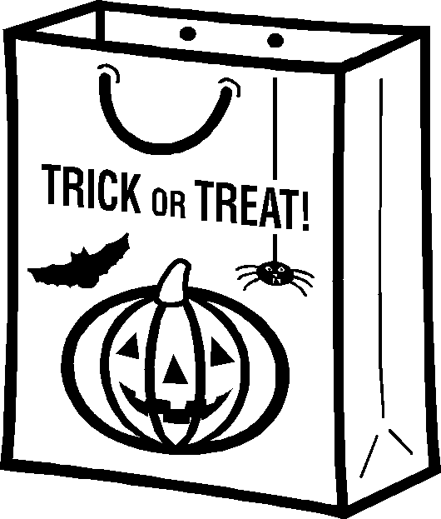
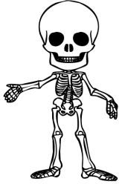
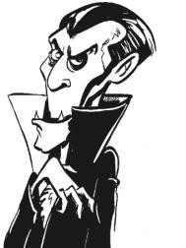

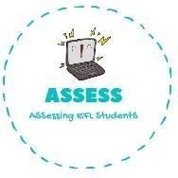
ENGLISH EXAM

Writing

Name: Surname: N^{ber}: Grade/Class:
Assessment: | Date:
 | Teacher’s signature:  _ | Parent’s signature:

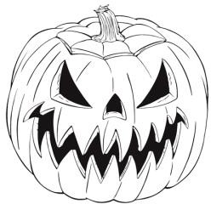
1. Order the words and paint these Halloween drawings!

a-j-k-c l-o-a-t-n-e-n-r
w-e-e-t-s
g-b-a
k-s-l-t-e-n-o-e
m-p-v-a-i-e-r

Assessing EFL Students

