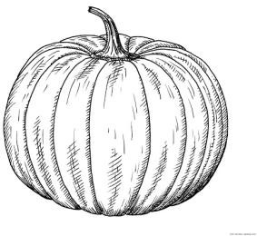
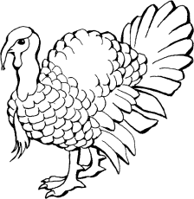
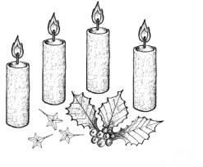

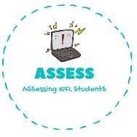
ENGLISH EXAM

Writing

Name: Surname: N^{ber}: Grade/Class:
Assessment: | Date:
 | Teacher’s signature:  _ | Parent’s signature:

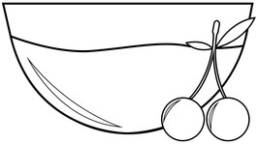
1. Order the words and paint these Thanksgiving drawings!

r-c-a-b-n-e-y-r-r a-u-s-e-c
u-m-p-p-n-i-k
s-p-a-e
u-t-r-e-y-k
a-c-n-l-d-e-s

Assessing EFL Students

