C

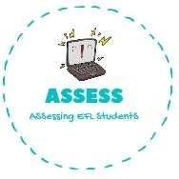
ENGLISH WORKSHEET

reading

TOPIC: CELEBRATIONS | SUBTOPICS: Bonfire Night (Culture bridge) | LEVEL: _A2
Name: Surname: N^{ber}: Grade/Class:

1. Put the letter in the corresponding word.
Guy Fawkes - Bonfire - Fireworks - Toffe apples - Sparklers -

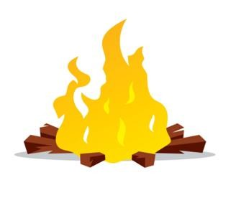
A
B

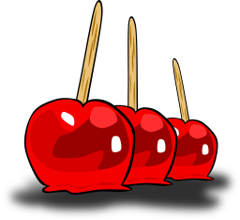
D
E

Assessing EFL Students

