TOPIC: CELEBRATIONS | SUBTOPICS: Christmas (Culture bridge) | LEVEL: _A2___
Name: ____________________________ Surname: ____________________________ N^{ber}: ____ Grade/Class: _____

- Match with arrows.
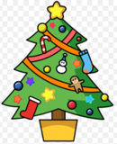
1-Star.
2-Christmas tree.
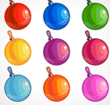
3-Father Christmas.
4-Ball.
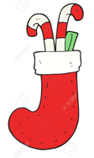
5-Reindeer.
6-Present.
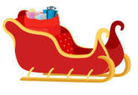
7-Sleigh.
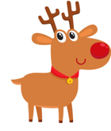
8- Stocking.

9- Bell.
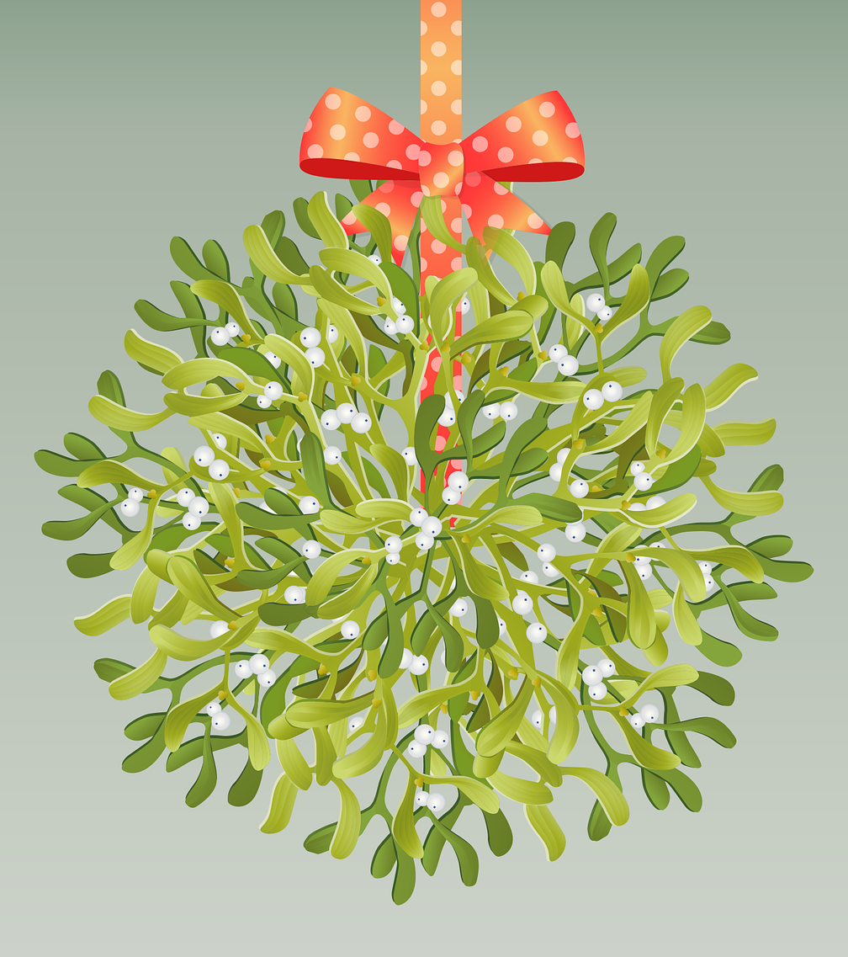
10- Mistletoe.

- Sing Christmas songs with your classmates.

