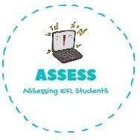
ENGLISH WORKSHEET
reading

TOPIC: CELEBRATIONS | SUBTOPICS: Easter (Culture bridge) | LEVEL: _A1
Name: Surname: N^{ber}: Grade/Class:

1. Write the name under the image.
Easter Bunny, basket, Easter egg and jelly beans.

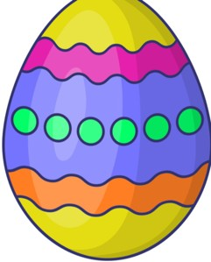

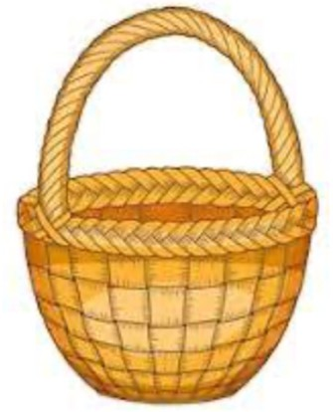
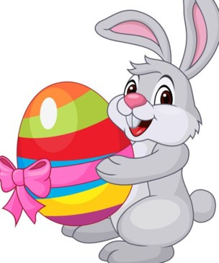

Assessing EFL Students

