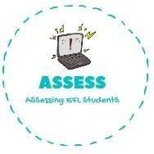
ENGLISH EXAM
Reading

Name: Surname: N^{ber}: Grade/Class:
Assessment: | Date:
 | Teacher’s signature:  _ | Parent’s signature:

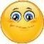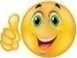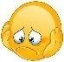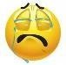Read and write True or False. Then correct the false sentences.

  - My friends give me presents in my birthday. →

  - There are never balloons on birthdays. →

  - There are always candles on top of the cake. →

  - Paper hats are made of plastic. →

  - There never is cake, children prefer fruit. →

Answer the questions.

  - When is your birthday? My birthday is the of .

  - How old are you? I am old.

  - Do you like celebrating your birthday? Why? .

  - Do you have paper hats? .

  - What do you like the most about birthdays? .

Assessing EFL Students

