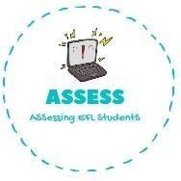
ENGLISH EXAM
Reading

Name: Surname: N^{ber}: Grade/Class:
Assessment: | Date:
 | Teacher’s signature:  _ | Parent’s signature:

Read and write True or False. Then correct the false sentences.

  - I eat toffee apples at the Bonfire Night. →

  - There are never fireworks during de bonfire night. →

  - People play with sparkles. →

  - Children cannot go to Bonfire Night. →

  - Everyone can go to Bonfire Night. →

Answer the questions.

  - Have you ever been to Bonfire Night? .

  - Do you like sparkles? .

  - What about fireworks? Do you enjoy them? .

  - Do you like bonfires? Why? Why not? .

  - What do find most interesting about Bonfire Night?
.

Assessing EFL Students

