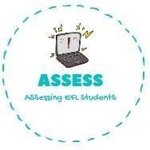
ENGLISH EXAM
Reading

Name: Surname: N^{ber}: Grade/Class:
Assessment: | Date:
 | Teacher’s signature:  _ | Parent’s signature:

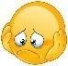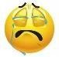Read and write True or False. Then correct the false sentences.

  - Nothing is scary in Halloween. →

  - There are no sweets in Halloween. →

  - People dress up in Halloween. →

  - People make faces on apples. They call them Jack O’lanterns. →

  - There are cats and bats during Halloween. →

Answer the questions.

  - What do you do in Halloween? In Halloween I .

  - What is your favourite Halloween costume? .

  - Do you ask for trick or treat? .

  - Do you like sweets? .

  - Are you scared of Halloween? Why/Why not? .

Assessing EFL Students

