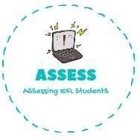
ENGLISH EXAM
Reading

Name: Surname: N^{ber}: Grade/Class:
Assessment: | Date:
 | Teacher’s signature:  _ | Parent’s signature:

Read and write True or False. Then correct the false sentences.

  - My favourite day is Pancake Friday. →

  - Pancakes are made of rice and water. →

  - You need flour and eggs to make pancakes. →

  - Milk is never necessary to make pancakes. →

  - My favourite day is Pancake Tuesday. →

Answer the questions.

  - Do you like pancakes? Why? .

  - How do you make a pancake? I mix f , e , m and s .

  - Can you make pancakes alone or do you need help? .

  - How do you like to eat your pancakes? With syrup, chocolate….
.

Assessing EFL Students

