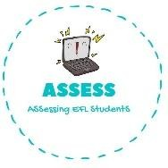
ENGLISH EXAM
Speaking

Name: Surname: N^{ber}: Grade/Class:
Assessment: | Date:
 | Teacher’s signature:  _ | Parent’s signature:

Let’s sing together.

Happy Birthday to you Happy Birthday to you Happy Birthday Dear (name) Happy Birthday to you.

Present this dialogue in pairs.

-How old are you?

-I’m years old

-When is your birthday?

-It’s on the 1st of June/2nd of September/4th of October/13th of February

Assessing EFL Students

