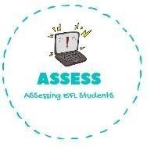
ENGLISH EXAM SPEAKING

Name: Surname: N^{ber}: Grade/Class:
Assessment: | Date:
 | Teacher’s signature:  _ | Parent’s signature:

1. Describe the picture to your partner.

What can you see in these pictures?

Assessing EFL Students

