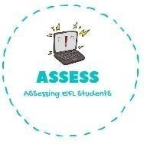
ENGLISH EXAM SPEAKING

Name: Surname: N^{ber}: Grade/Class:
Assessment: | Date:
 | Teacher’s signature:  _ | Parent’s signature:

1. Answer the questions.

What is Harry Potter? Harry Potter is a
What is Dracula? Dracula is a
What do you say in Halloween?

Who is in the picture? There is a

Assessing EFL Students

