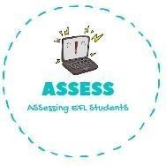
ENGLISH EXAM SPEAKING

Name: Surname: N^{ber}: Grade/Class:
Assessment: | Date:
 | Teacher’s signature:  _ | Parent’s signature:

1. Ask your partner.

Do you like pancakes? Yes, I do/ No, I don’t
What are these ingredients?

What do you need to cook the pancake? You need a

Assessing EFL Students

