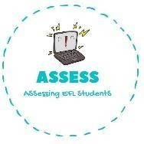
1. Answer the questions.
Name: Surname: N^{ber}: Grade/Class:
Assessment: | Date:
 | Teacher’s signature: | Parent’s signature:

ENGLISH EXAM
Writing

- When is your birthday? My .

- How old are you? old.

- Do you know the birthday song? Yes, I do/ No, I don’t.

- What is your favourite present? My favourite present is .

- What can you see in birthday parties? I can see b , p , h and a c .

2. Complete the words.
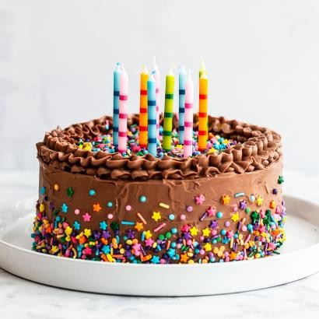
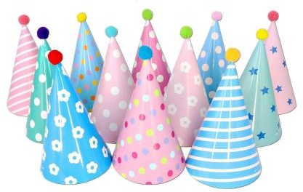

B_ _ _ _ _ _ _ C _ _ _ P _ _ _ _ _ _ P _ _ _ _ H _ _ _

Assessing EFL Students

