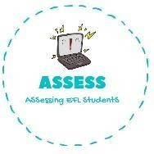
ENGLISH EXAM
Writing

Name: Surname: Nber: Grade/Class:
Assessment: | Date:
 | Teacher’s signature: | Parent’s signature:

1. Find the words in the puzzle and write them.

B | M | O | F | T | E | A | R | J | U | F | Q
T | O | F | F | E | E | A | P | P | L | E | S
A | Q | N | D | C | E | T | H | B | I | O | U
S | D | A | F | I | R | E | W | O | R | K | S
K | L | H | J | I | A | E | R | V | C | F | A
N | J | S | P | A | R | K | L | E | S | Z | A
K | O | J | L | G | F | E | S | A | E | I | R
1. B _ _ _ _ _ _

2. S _ _ _ _ _ _ _

3. F _ _ _ _ _ _ _ _

4. T _ _ _ _ _ A _ _ _ _ _

Assessing EFL Students

