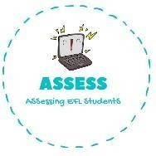
1. Order the words.
Name: Surname: N^{ber}: Grade/Class:
Assessment: | Date:
 | Teacher’s signature: | Parent’s signature:

- Vee s’Earsy Wen ->

ENGLISH EXAM
Writing

- Tsmchrais ->

- Espntre -->

- Toesmlite ->

2. What is it?

R _ _ _ _ _ _ _ C _ _ _ _ _ _ _ _ T _ _ _ S _ _ _ _ _

Assessing EFL Students

