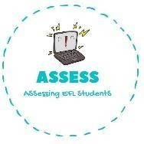
1. Answer the questions.
Name: Surname: N^{ber}: Grade/Class:
Assessment: | Date:
 | Teacher’s signature: | Parent’s signature:

ENGLISH EXAM
Writing

- What is your favourite costume for Halloween?
.

- What monsters can you see in Halloween?
I can see w , v , g ettc

- Do you decorate your house? Do you like it?
.

2. Complete the song using the words.
Halloween – come – strange – night – this – is Boys and girls of every age
Wouldn’t you like to see something
with us and you will see, This is our town of

This is Halloween,
Pumpkins scream in the dead of
Halloween,
.

Assessing EFL Students

