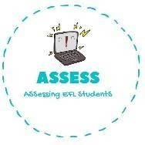
ENGLISH EXAM
Writing

Name: Surname: Nber: Grade/Class:
Assessment: | Date:
 | Teacher’s signature: | Parent’s signature:

Complete or answer the questions.

I make p with a f p

What ingredients do you use to make a pancake? I use f , e , s and m . Do you like pancake Tuesdays? Why?

Complete the words.

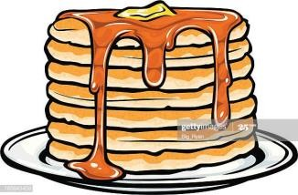
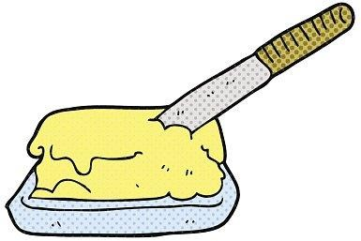
F_ _ _ _ _ p _ _ P _ _ _ _ _ _ B _ _ _ _ _
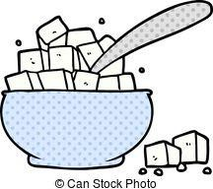
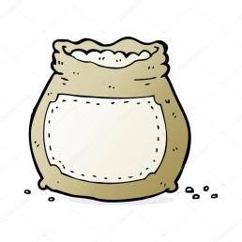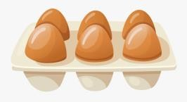
S _ _ _ _ M _ _ _ L _ _ _ _ _ F _ _ _ _ E _ _ _

Assessing EFL Students

