Name: ____________________________ Surname: ____________________________ N^{ber}: ____ Grade/Class: _____
Assessment: _____________________________ | Date: ___________________________________________________
 | Teacher’s signature:  ___________________________ | Parent’s signature:  ___________________________

Listen and tick.

- What’s her favourite season?
a) b) c)

33
- How many hats are there?
23
25
a) b) c)
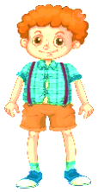

- Who is Mike?
a) b) c)

- Where’s the cap?
a) b) c)

- What does she like wearing?
a) b) c)

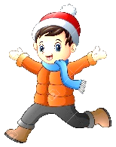
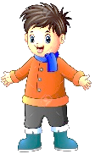

- Who is Peter?
a) b) c)

- What is he wearing?
a) b) c)

TRANSCRIPT

EXERCISE 1

ONE
Boy: What’s your favourite season?
Girl: I like winter to play in the snow but my favourite season is summer. I love wearing skirts and dresses.

TWO
Boy: It’s very hot today. We need hats. How many hats are there?
Girl: 23, I think.

THREE
Mum: What a wonderful spring day! It’s sunny and warm.
Mike: Can I put on my white shirt?
Mum: Sure!

FOUR
Boy: Where’s my cap?
Girl: Look over there. It’s near the box.

FIVE
Boy: What clothes do you like in summer? Do you like dresses?
Girl: No, I don’t. I like wearing shorts and T-shirts.

SIX
Girl: It’s snowy and freezing. Peter, put on your coat, a woolly hat and a scarf.
Boy: Ok. My coat, a woolly hat and a scarf. I’m ready, let’s go.

SEVEN
Teacher: It’s windy and chilly today. I’m wearing a jumper, trousers and a jacket.

ANSWER KEY

- c
- a
- a
- b
- c
- a
- b

