Name: ____________________________ Surname: ____________________________ N^{ber}: ____ Grade/Class: _____
Assessment: _____________________________ | Date: ___________________________________________________
 | Teacher’s signature:  ___________________________ | Parent’s signature:  ___________________________

- Listen and number.

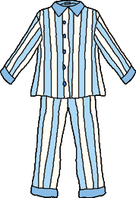
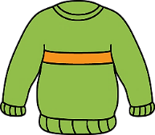
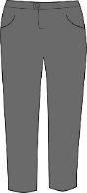
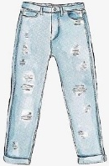

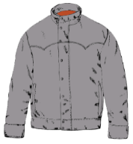
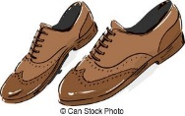

- Listen and tick.
- What’s the weather like?
a) b) c)

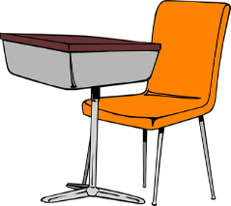
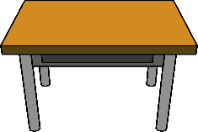
- Where’s my sock?
a) b) c)

- How many jackets are there?
7
5
2
a) b) c)

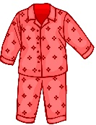

- Which pyjamas is he wearing?
a) b) c)

- Who’s the teacher?
a) b) c)

TRANSCRIPT

EXERCISE 1

- Shoes
- Jumper
- Jeans
- Pyjamas
- Trousers
- Socks
- Jacket

EXERCISE 2

ONE
Today it’s the first day of school. It’s sunny and warm.

TWO
- Where is my sock? I can’ find it.
- Look, it’s on the chair.

THREE
Look there are five jackets on the table and two jumpers.

FOUR
Today I’m wearing my red pyjamas. Good night!

FIVE
Look this is Mr. Brown. He is the new teacher. He is wearing a jacket, a jumper, trousers and shoes.

ANSWER KEY

EXERCISE 1

2 | 5 | 3 | 4

6 | 7 | 1

EXERCISE 2

- b
- c
- b
- a
- c

