Name: ____________________________ Surname: ____________________________ N^{ber}: ____ Grade/Class: _____
Assessment: _____________________________ | Date: ___________________________________________________
 | Teacher’s signature:  ___________________________ | Parent’s signature:  ___________________________

- Listen and number.
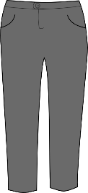
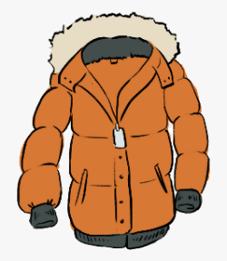
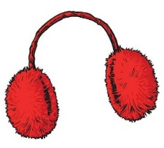
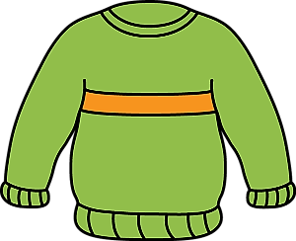

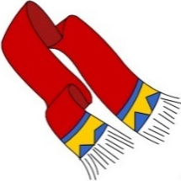
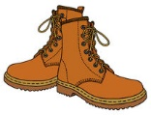
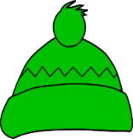
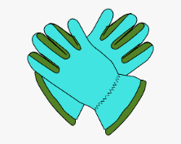

- Listen, link and colour.
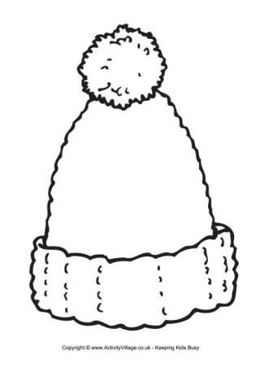
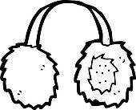

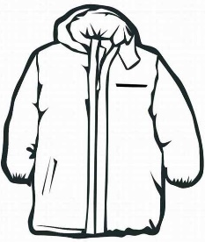
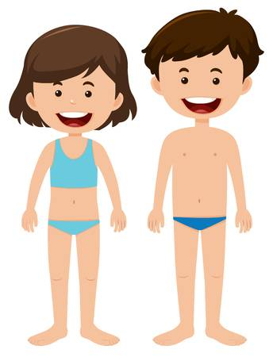

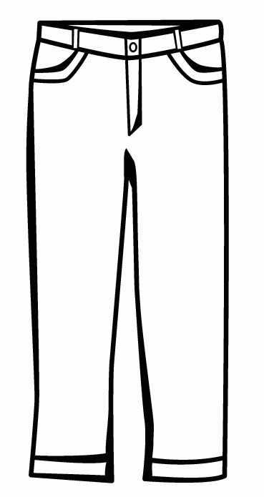

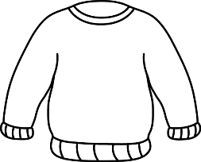

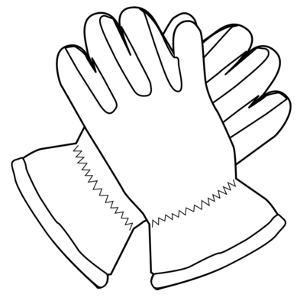

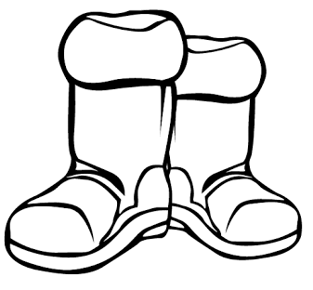
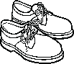

TRANSCRIPT

EXERCISE 1

- Woolly hat
- Jumper
- Coat
- Boots
- Trousers
- Earmuffs
- Gloves
- Scarf

EXERCISE 2

Today it’s snowy and it’s very cold.
Kathy is wearing a blue coat, pink trousers and black boots.
She’s also wearing a purple woolly hat, purple scarf and white gloves.

ANSWER KEY

EXERCISE 1

2 | 6 | 3 | 5
4 | 8 | 7 | 1

EXERCISE 2

a blue coat, pink trousers and black boots
a purple woolly hat, purple gloves and white gloves

