Name: ____________________________ Surname: ____________________________ N^{ber}: ____ Grade/Class: _____
Assessment: _____________________________ | Date: ___________________________________________________
 | Teacher’s signature:  ___________________________ | Parent’s signature:  ___________________________

- Listen and number.
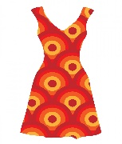
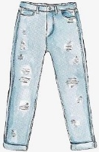
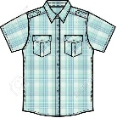

- Listen and tick.

- What season is it?
a) b) c)

- Where’s the T-shirt?
a) b) c)

- What is Peter wearing?
a) b) c)

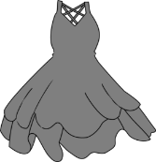
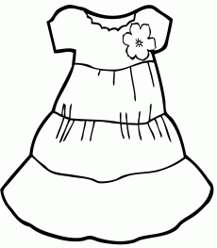
- What is her favourite dress?
a) b) c)

- What’s the weather like today?
a) b) c)

TRANSCRIPT

EXERCISE 1

- Trainers
- Dress
- Jeans
- T-shirt
- Sandals
- Tracksuit
- Shirt
- Blouse

EXERCISE 2

ONE
Boy: Oh it’s so warm and sunny today.
Girl: Yeah! I love spring.

TWO
Boy: Mum, where’s my T-shirt?
Mum: Look over there. It’s on the box.

THREE
Boy: Where’s Peter?
Girl: Look there’s Peter. He’s wearing trousers, a shirt and trainers.

FOUR
Girl: Oh I love that dress!
Boy: Which one? The grey one??
Girl: No, the white one.

FIVE
Boy: Hi mum, what’s the weather like today?
Mum: It’s misty.

ANSWER KEY

EXERCISE 1

7 | 2 | 3 | 6
4 | 5 | 8 | 1

EXERCISE 2

- c
- b
- a
- c
- a

