Name: ____________________________ Surname: ____________________________ N^{ber}: ____ Grade/Class: _____
Assessment: _____________________________ | Date: ___________________________________________________
 | Teacher’s signature:  ___________________________ | Parent’s signature:  ___________________________
- Listen and colour.
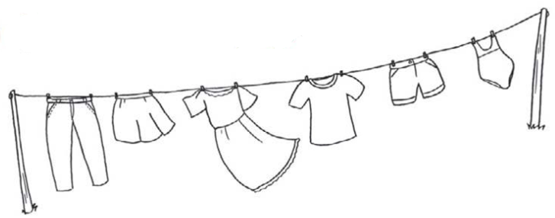

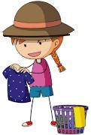

- Listen and link.

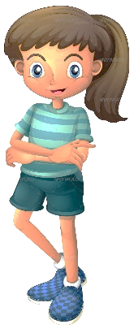
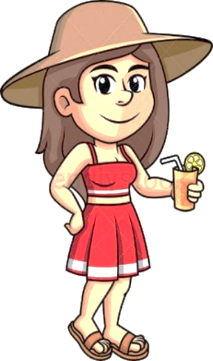

. . . . .

. . . . .
Kathy

Melissa

Helen

Anne

Carol

TRANSCRIPT

EXERCISE 1

Look, Mary is hanging the washing on the rope.
Can you see the trousers? Colour the trousers in green.
The skirt is orange and yellow.
The dress is pink.
The T-shirt is red.
The shorts are blue.
The swimsuit is purple.

EXERCISE 2

- Helen is wearing a red dress, a hat and sandals.
- Melissa is wearing shorts, a T-shirt, a cap and trainers.
- Carol is wearing a blue skirt, a blouse and flip flops.
- Kathy is wearing a purple dress and black sunglasses.
- Anne is wearing a hat, a swimsuit and flip flops.

ANSWER KEY

EXERCISE 1

Trousers – green
Skirt - orange and yellow
Dress - pink
Skirt - red
Shorts - blue
Swimsuit - purple

EXERCISE 2

1st girl |  | 2nd girl | 3rd girl | 4th girl | 5th girl
Carol |  | Helen | Melissa | Kathy | Anne

