Name: ____________________________ Surname: ____________________________ N^{ber}: ____ Grade/Class: _____
Assessment: _____________________________ | Date: ___________________________________________________
 | Teacher’s signature:  ___________________________ | Parent’s signature:  ___________________________

- Listen and number.
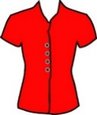
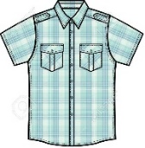
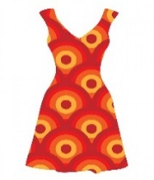
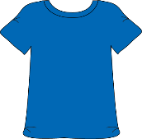

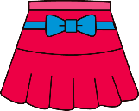
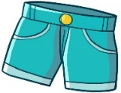
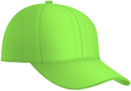
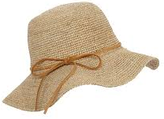

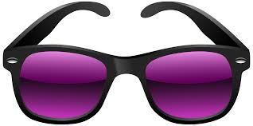
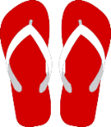

- Listen, link and colour.
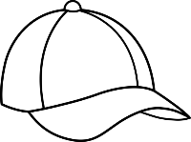
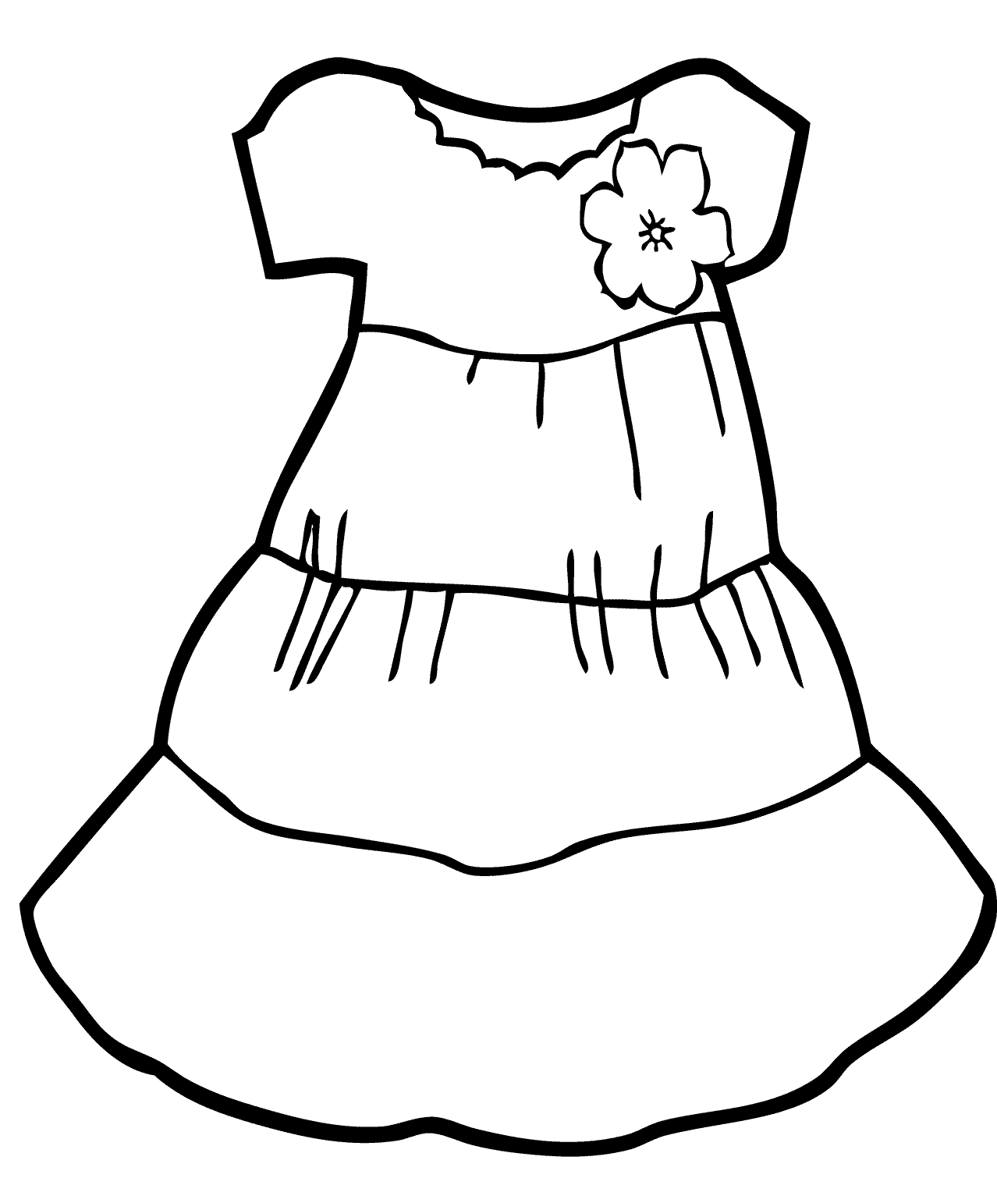

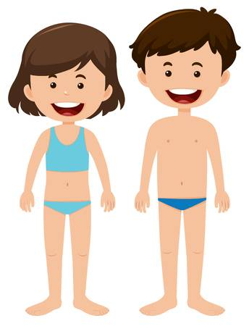

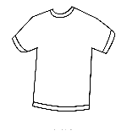
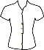

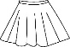

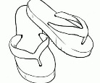
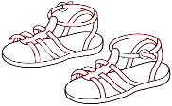

TRANSCRIPT

EXERCISE 1

- Shorts
- T-shirt
- Glasses
- Flip flops
- Dress
- Cap
- Blouse
- Shirt
- Hat
- Sandals
- Skirt
- Swimsuit

EXERCISE 2

It’s a fantastic summer day. It’s sunny and hot.
Sally is wearing a pink blouse, a yellow skirt and red sandals.
She’s wearing a blue cap and black sunglasses.

ANSWER KEY

EXERCISE 1

2 | 8 | 7 | 5
11 | 1 | 9 | 6
3 | 4 | 12 | 10

EXERCISE 2

a pink blouse, a yellow skirt and red sandals
a blue cap and black sunglasses

