Name: ____________________________ Surname: ____________________________ N^{ber}: ____ Grade/Class: _____
Assessment: _____________________________ | Date: ___________________________________________________
 | Teacher’s signature:  ___________________________ | Parent’s signature:  ___________________________

- Listen and colour.

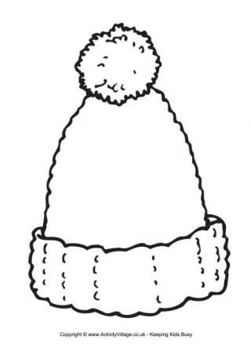
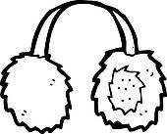

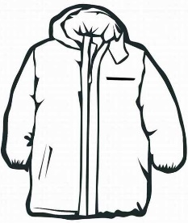

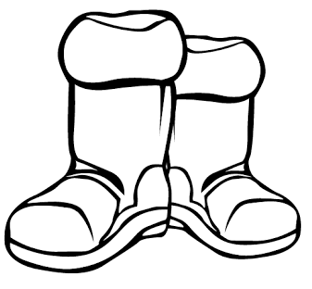
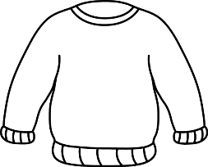
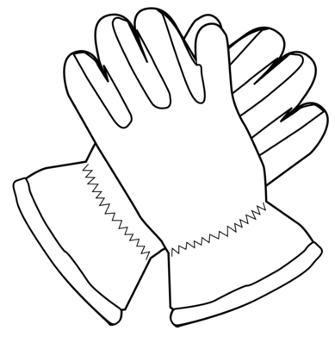

- Listen and link.
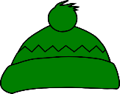
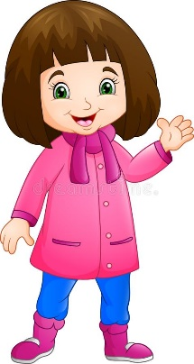
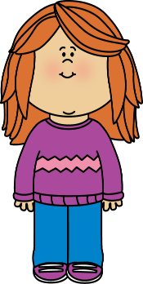

. . . .

. . . .
Melissa

Kate

Mary

Jenny

TRANSCRIPT

EXERCISE 1

One
Teacher –Look at the picture. Can you see the scarf?
Mary – Yes, I can.
Teacher – Colour the scarf yellow.
Mary – Pardon?
Teacher – Colour the scarf yellow.
Mary – OK.

Two
Teacher – Look at the woolly hat.
Mary – Can I colour it?
Teacher – Yes. Colour the woolly hat purple!
Mary – Of course.

Three
Teacher – Now colour the boots.
Mary – What colour?
Teacher – Black.
Mary – Ok. Black boots.

Four
Teacher – Can you see the earmuffs?
Mary – Yes.
Teacher – Colour the earmuffs pink.
Mary – Ok, pink earmuffs. I love pink!

Five
Mary – Can I colour the coat?
Teacher – Yes. Colour the coat in blue.
Mary – A blue coat!

EXERCISE 2

- Melissa is wearing a woolly hat, a jumper, trousers, and shoes.
- Kate is wearing a blue coat, a scarf, boots and pink earmuffs.
- Jenny is wearing a coat, a scarf, a woolly hat and gloves.
- Mary is wearing a pink coat, a pink scarf and pink boots

ANSWER KEY

EXERCISE 1

scarf - yellow
woolly hat - purple
boots - black
earmuffs - pink
coat - blue

EXERCISE 2

1st girl | 2nd girl | 3rd girl | 4th girl
Mary | Melissa | Kate | Jenny

