Name: ____________________________ Surname: ____________________________ N^{ber}: ____ Grade/Class: _____
Assessment: _____________________________ | Date: ___________________________________________________
 | Teacher’s signature:  ___________________________ | Parent’s signature:  ___________________________

Complete the speech bubble. Then circle the clothes Karen likes according to the season.
Hello! My name’s Karen.
My favourite season is ____________________
and the season I don’t like is _______________.

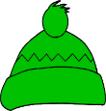
Winter
Autumn
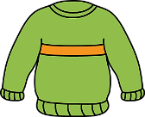

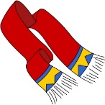
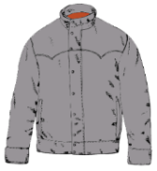
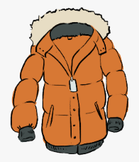

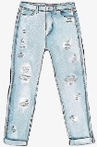
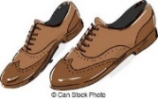
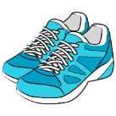
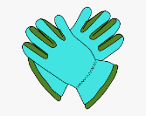
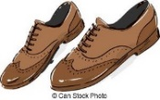
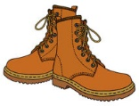

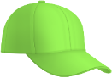
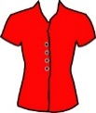
Summer
Spring
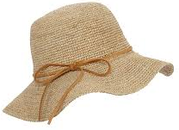
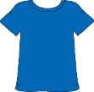

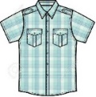
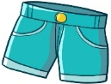
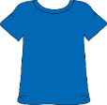
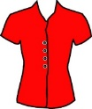
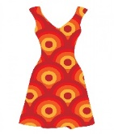
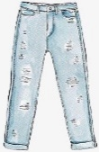
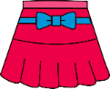
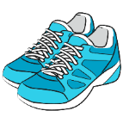
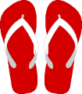

TRANSCRIPT

EXERCISE 1

Hello! My name’s Karen and my favourite season is summer. It’s always sunny and very hot.
In summer, I love wearing T-shirts with shorts or skirts and sandals.

In autumn, it’s chilly and windy. I like collecting leaves.
In autumn, I like wearing jeans, a jacket and shoes.

In spring it’s warm and there are flowers and butterflies.
In spring, I like wearing a tracksuit and trainers to pick flowers and catch butterflies.

I don’t like winter. It’s very cold and sometimes it’s freezing!
I like wearing warm clothes, for example, my brown coat, a woolly hat and boots to run in the snow.

ANSWER KEY

Hello! My name’s Karen.
My favourite season is summer
and the season I don’t like is winter.

Summer: T-shirts, shorts, skirts and sandals
Autumn: jeans, a jacket and shoes
Spring: a tracksuit and trainers
Winter: coat, a woolly hat and boots

