Name: ____________________________ Surname: ____________________________ N^{ber}: ____ Grade/Class: _____
Assessment: _____________________________ | Date: ___________________________________________________
 | Teacher’s signature:  ___________________________ | Parent’s signature:  ___________________________

- Listen and colour.

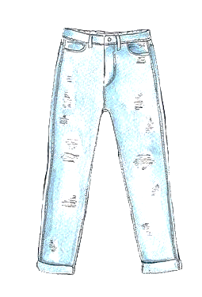

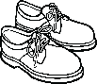
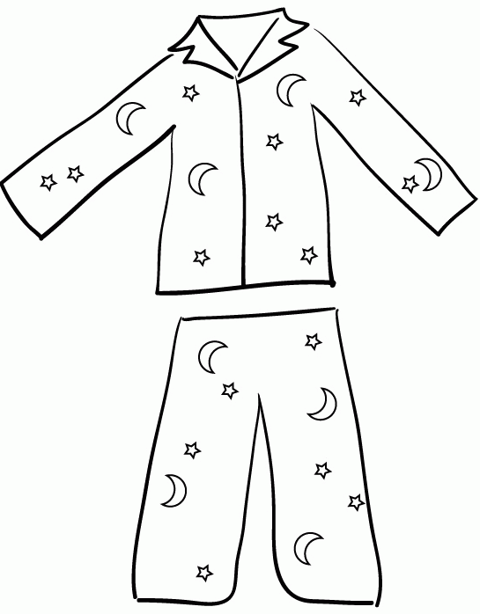

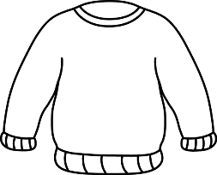

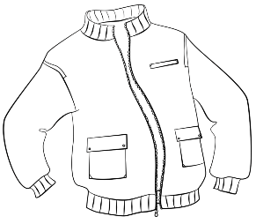
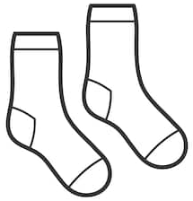

- Listen and link.

. . .

. . .
James

Peter

Tom

TRANSCRIPT

EXERCISE 1

One
Teacher –Look at the picture. There is a pair of jeans. Can you see the jeans?
Mary – Yes, I can.
Teacher – Colour the jeans grey.
Mary – Pardon?
Teacher – Colour the jeans grey.
Mary – OK.

Two
Teacher – Look at the jumper.
Mary – Can I colour it?
Teacher – Yes. Colour the jumper orange!
Mary – Of course.

Three
Teacher – Now colour the shoes.
Mary – What colour?
Teacher – Brown.
Mary – Ok. Brown shoes.

Four
Teacher – Can you see the jacket?
Mary – Yes.
Teacher – Colour the jacket red.
Mary – Ok, a red jacket. I love red!

Five
Mary – Can I colour the socks?
Teacher – Yes. Just one. Colour one sock in yellow.
Mary – One sock yellow!

EXERCISE 2

- Peter is wearing blue trousers, a jumper, a red jacket and shoes.
- James is wearing a green jumper, blue trousers and shoes.
- Look, Tom is sleepy, he is wearing his blue pyjamas.

ANSWER KEY

EXERCISE 1

- Jeans – grey
- jumper – orange
- shoes – brown
- jacket – red
- socks – yellow

EXERCISE 2

1st boy – James / 2nd boy – Peter / 3rd boy – Tom

