Name: ____________________________ Surname: ____________________________ N^{ber}: ____ Grade/Class: _____
Assessment: _____________________________ | Date: ___________________________________________________
 | Teacher’s signature:  ___________________________ | Parent’s signature:  ___________________________

Look at the picture. Write Yes or No.
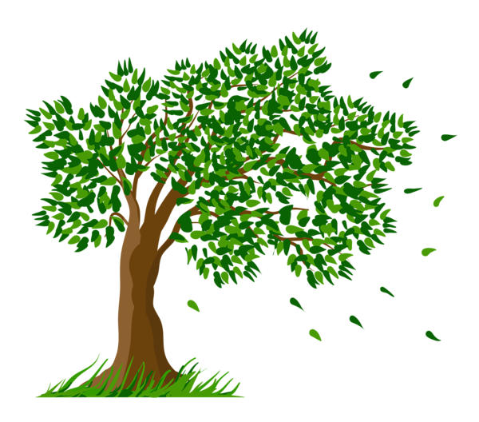

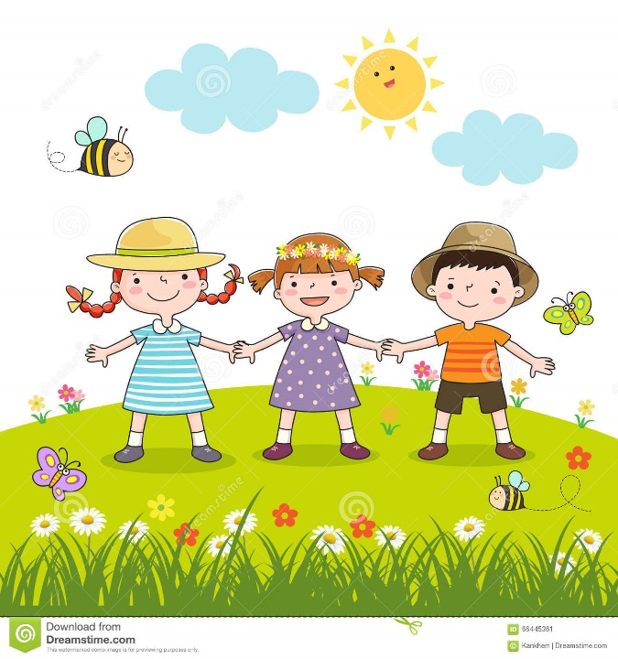
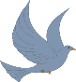

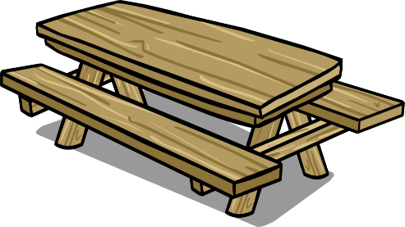
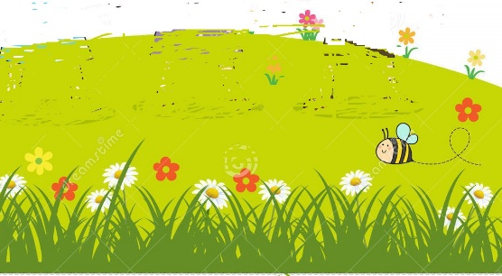

a) It’s spring. _______
b) It’s sunny and chilly. _______
c) The boy is wearing a T-shirt and trousers. ______
d) The girls are wearing dresses. _______
e) One girl is wearing sandals. _______
f) There is a bird on the table. _______
g) There are butterflies and bees. _______
h) The boy is picking flowers. _______

ANSWER KEY

- Yes
- No
- No
- Yes
- No
- Yes
- Yes
- No

