Name: ____________________________ Surname: ____________________________ N^{ber}: ____ Grade/Class: _____
Assessment: _____________________________ | Date: ___________________________________________________
 | Teacher’s signature:  ___________________________ | Parent’s signature:  ___________________________

- Read, draw and colour.
a) d)

- These are green trousers.
- These are orange socks.
- These are red pyjamas.
- This is a grey jacket.

b) e)

- These are brown shoes.

c) f)

- This is a yellow jumper.

- Read and link.
Under the desk.
What colour is the jumper?
1) A

How many shoes are there?
2) B

It’s red.

3) C

Four.
Where is my jacket?

4) D

A sock.
What’s this?

ANSWER KEY

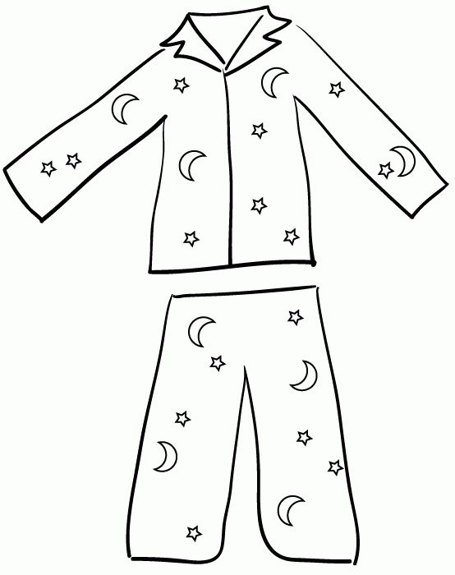
EXERCISE 1

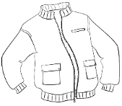
- grey d) red

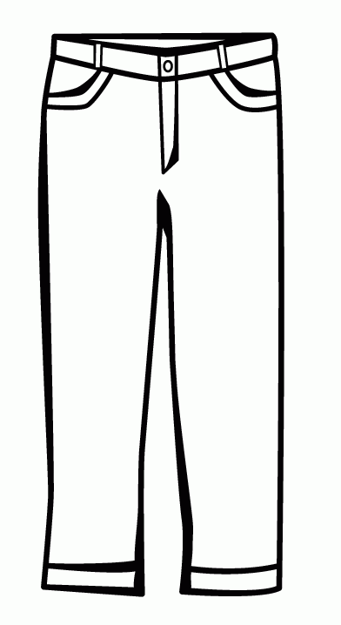
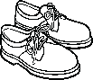
- brown e) green

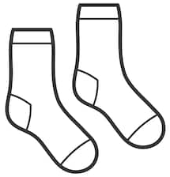
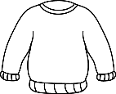
- yellow f) orange

EXERCISE 2

- b
- c
- a
- d

