Name: ____________________________ Surname: ____________________________ N^{ber}: ____ Grade/Class: _____
Assessment: _____________________________ | Date: ___________________________________________________
 | Teacher’s signature:  ___________________________ | Parent’s signature:  ___________________________

- Read, match and colour.
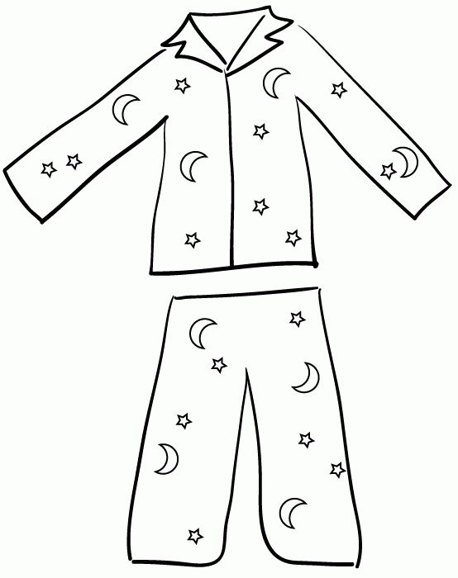
- The shoes are brown.
- This is a red jumper.
- My jacket is green.
- The pyjamas are orange.
- These are yellow socks.
- My trousers are grey.
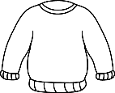

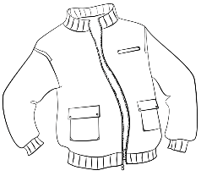
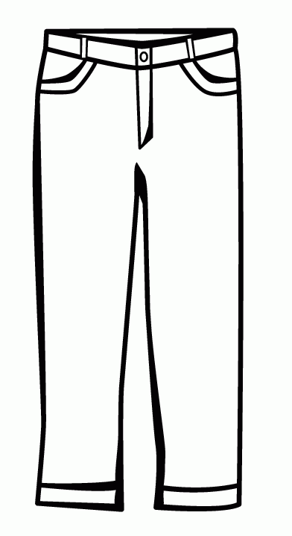

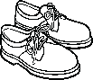
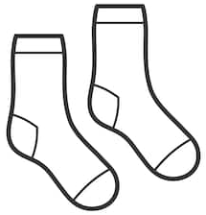

2) Read and look. Put a tick ( ) or a cross ( ).

- There are five socks. b) The boy is wearing pyjamas.
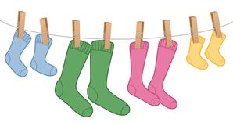
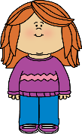
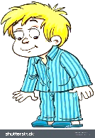

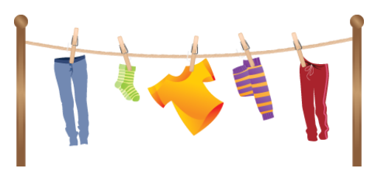
c) There are two trousers and one jumper.

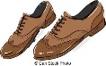
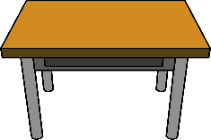
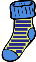
d) It’s windy. The boy is wearing a jacket. e) The shoes are under the table.
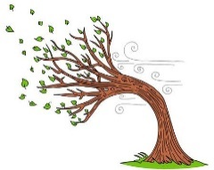

ANSWER KEY

EXERCISE 1

- The shoes are brown.

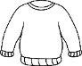
- This is a red jumper.

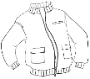
- My jacket is green.

- The pyjamas are orange.

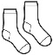
- These are yellow socks.

- My trousers are grey.

EXERCISE 2

- Cross
- Tick
- Cross
- Tick
- Tick

