TOPIC: Clothes | SUBTOPICS: spring/summer clothes, colours | LEVEL: A1
Name: ____________________________ Surname: ____________________________ N^{ber}: ____ Grade/Class: _____

WHAT ARE YOU WEARING?

Read and colour.
I’m wearing a blue dress, a yellow hat and pink sandals.
I’m wearing orange shorts a green T-shirt and brown sandals.

I’m wearing a grey jumper, a blue skirt and black shoes.
I’m wearing black trousers, a white T-shirt and purple sandals.

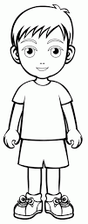
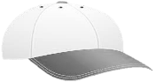
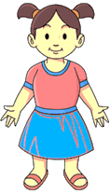
I’m wearing green shorts, a white T-shirt and an orange cap.
I’m wearing a red T-shirt, a blue skirt and red sandals.

