TOPIC: Clothes | SUBTOPICS: spring/summer clothes; colours | LEVEL: A1
Name: ____________________________ Surname: ____________________________ N^{ber}: ____ Grade/Class: _____

WHAT IS SHE WEARING?

Read and match.
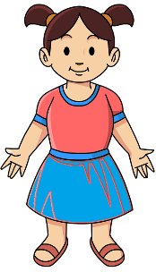

She’s wearing a pink T-shirt, a blue skirt, and red sandals.

She’s wearing a white dress, a pink hat and white sandals.

She’s wearing a purple dress and blue shoes.

She’s wearing blue jeans, a grey
T-shirt, trainers and sunglasses.

She’s wearing yellow shorts a yellow cap and sandals.

She’s wearing blue trousers, a red T-shirt, a blue cap and sandals.

