Name: ____________________________ Surname: ____________________________ N^{ber}: ____ Grade/Class: _____
Assessment: _____________________________ | Date: ___________________________________________________
 | Teacher’s signature:  ___________________________ | Parent’s signature:  ___________________________

- Read and colour.
Look, these are my friends, Liza and James.
Liza is wearing a yellow dress and red sandals. James likes sports. Today he’s wearing a green tracksuit and blue trainers.

2) Read and look at the pictures. Tick “yes” or “No”.

a) These are black trainers. b) There is a shirt on the washing line.
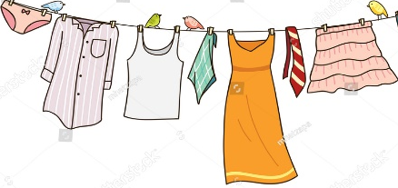
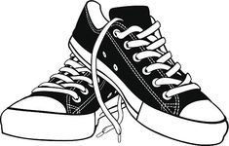
Yes
No
Yes
No

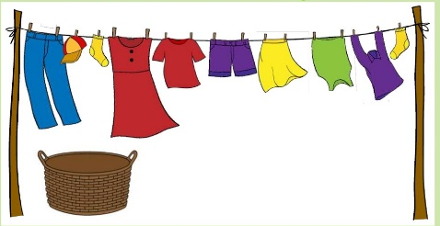
c) There is one dress and one skirt.
Yes
No

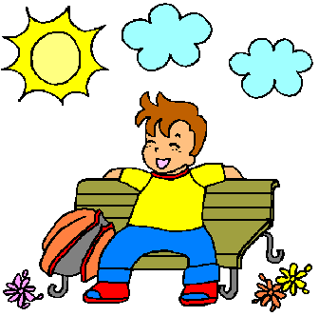
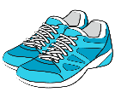
d) The sandals are on the box. e) It’s sunny and warm. He’s wearing a blouse.
Yes
No
Yes
No

ANSWER KEY

EXERCISE 1

Liza - a yellow dress and red sandals
James - a green tracksuit and blue trainers

EXERCISE 2

- Yes
- Yes
- Yes
- No
- No

