Name: ____________________________ Surname: ____________________________ N^{ber}: ____ Grade/Class: _____
Assessment: _____________________________ | Date: ___________________________________________________
 | Teacher’s signature:  ___________________________ | Parent’s signature:  ___________________________

- Read and colour.

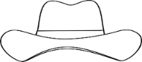
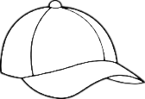
This is Suzy and her brother, Simon. It´s very hot today.
Suzy is wearing a yellow T-shirt, a red skirt, a pink hat and white sandals.
Simon is wearing blue shorts, a green T-shirt, a black cap and grey trainers.

2) Read and write the names.

b) ___________
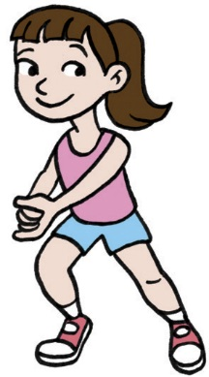
a) __________
My name is Anne. I’m wearing
a purple dress, a hat and sandals.

My name is Sally. I’m wearing
a skirt, a jumper and purple boots.

My name is Tina. I’m wearing
blue shorts and red trainers.

c) __________

e) __________

d) ___________
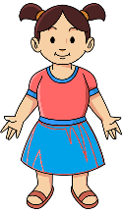
My name is Rose. I’m wearing a skirt, a pink T-shirt and sandals.

My name is Patricia. I’m wearing
white shorts, a hat and sandals.

ANSWER KEY

EXERCISE 1

Suzy: a yellow T-shirt, a red skirt, a pink hat and white sandals.
Simon: blue shorts, a green T-shirt, a black cap and grey trainers.

EXERCISE 2

Anne - B
Sally - E
Tina - A
Rose - D
Patricia - C

