Name: ____________________________ Surname: ____________________________ N^{ber}: ____ Grade/Class: _____
Assessment: _____________________________ | Date: ___________________________________________________
 | Teacher’s signature:  ___________________________ | Parent’s signature:  ___________________________

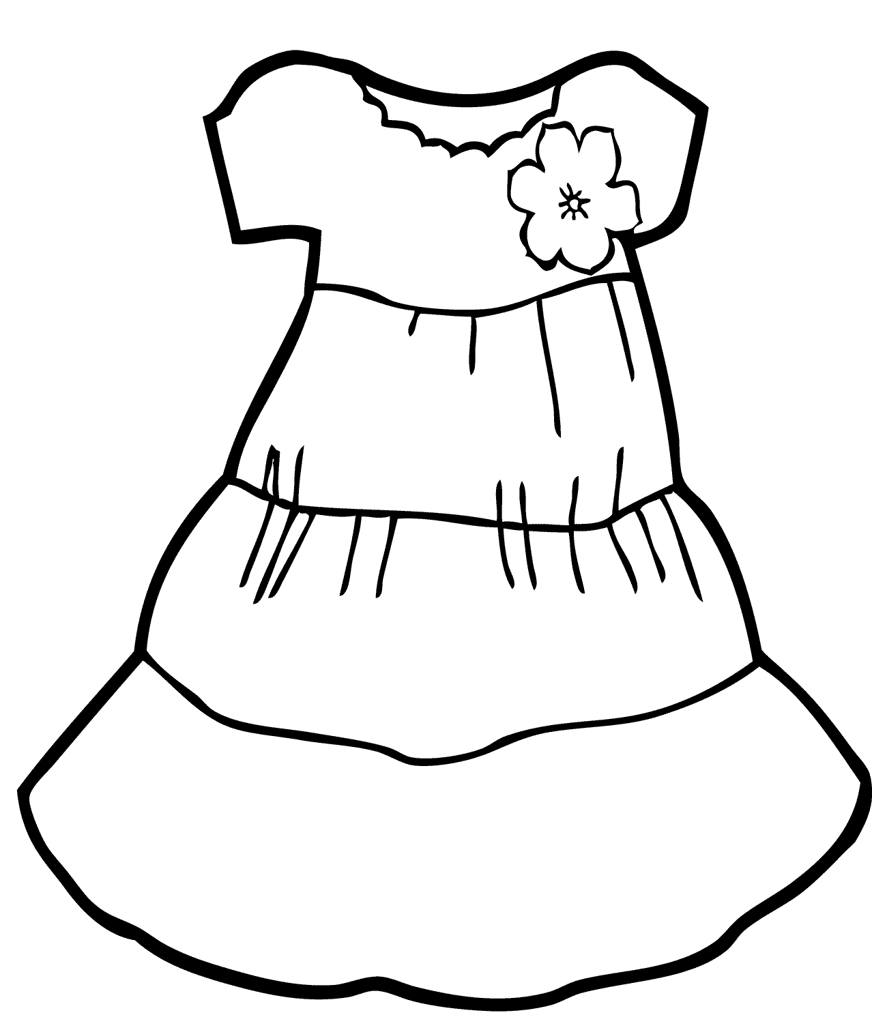
Read, tick and colour.
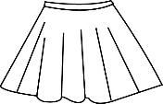
- This is a red dress. A B C

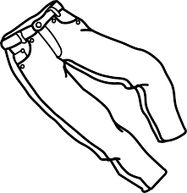
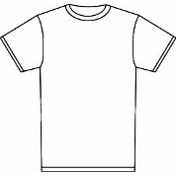
- These are green shorts. A B C

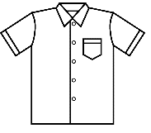
- This is a yellow shirt. A B C

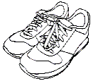
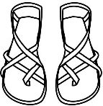
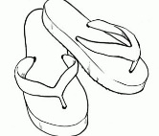
- These are black flip flops. A B C

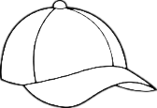
- This is a purple skirt A B C

- This is a pink swimsuit. A B C

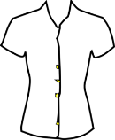
- This is a blue blouse. A B C

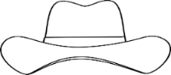
- This is a brown cap. A B C

ANSWER KEY

- c
- a
- b
- c
- c
- a
- b
- a

