Name: ____________________________ Surname: ____________________________ N^{ber}: ____ Grade/Class: _____
Assessment: _____________________________  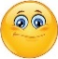 | Date: ___________________________________________________
 | Teacher’s signature:  ___________________________ | Parent’s signature:  ___________________________

- Read and colour.

This is Mary and her brother, Tom. It´s freezing and they are wearing warm clothes. Mary is wearing a pink coat, purple earmuffs and black boots. Tom is wearing a blue woolly hat, a brown scarf and grey gloves.

2) Read and write the names.
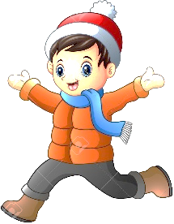
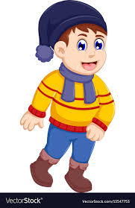
e) ____________
c) ____________
d) ____________
b) ____________
a) ____________
Paul is wearing a yellow jumper, a scarf, a woolly hat and boots.
Jack is wearing an orange jumper, a woolly hat, gloves and shoes.
Jason is wearing a coat, a scarf, a woolly hat, gloves and black shoes.
Mike is wearing a blue jumper, blue earmuffs, and a scarf.
Tom is wearing an orange coat, a woolly hat, a scarf and brown boots.

ANSWER KEY

EXERCISE 1

Mary: a pink coat, purple earmuffs and black boots.
Tom: a blue woolly hat, a brown scarf and grey gloves.

EXERCISE 2

Tom – A
Mike – E
Jason – B
Jack – D
Paul – C

