Name: ____________________________ Surname: ____________________________ N^{ber}: ____ Grade/Class: _____
Assessment: _____________________________ | Date: ___________________________________________________
 | Teacher’s signature:  ___________________________ | Parent’s signature:  ___________________________

Look at the picture. Write Yes or No.
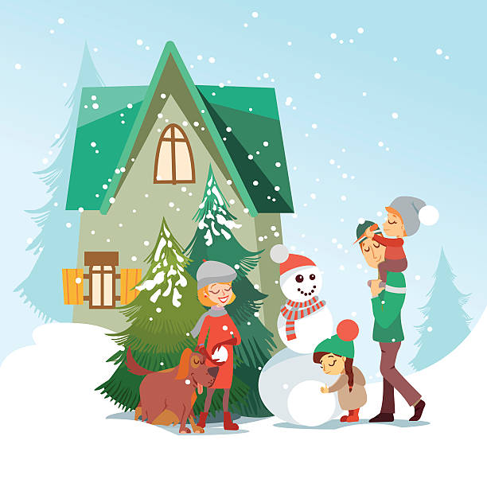

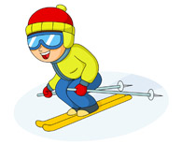

a) It’s winter. _______
b) It’s rainy and freezing. _______
c) There are two children. _______
d) The snowman is wearing a scarf. _______
e) There is snow. _______
f) The children are wearing woolly hats. _______
g) The mother is wearing earmuffs. _______
h) The father is wearing gloves and boots. _______
ANSWER KEY

- Yes
- No
- No
- Yes
- Yes
- Yes
- Yes
- No

