Name: ____________________________ Surname: ____________________________ N^{ber}: ____ Grade/Class: _____
Assessment: _____________________________ | Date: ___________________________________________________
 | Teacher’s signature:  ___________________________ | Parent’s signature:  ___________________________

- GROUP DISCUSSION

Talk about the pictures: season, weather, clothes they are wearing.

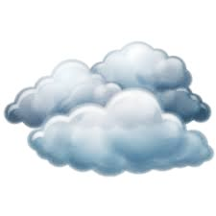  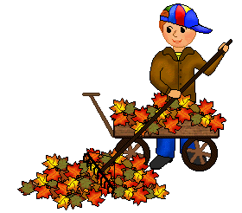  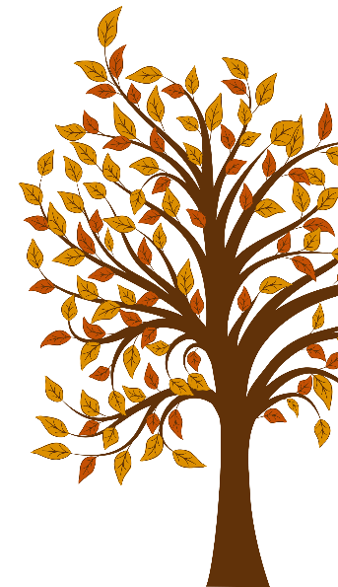  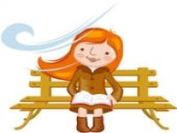 | 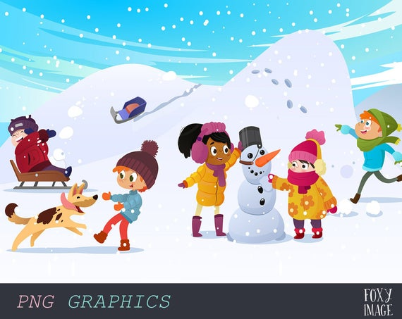
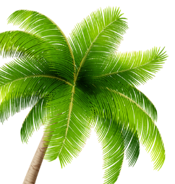  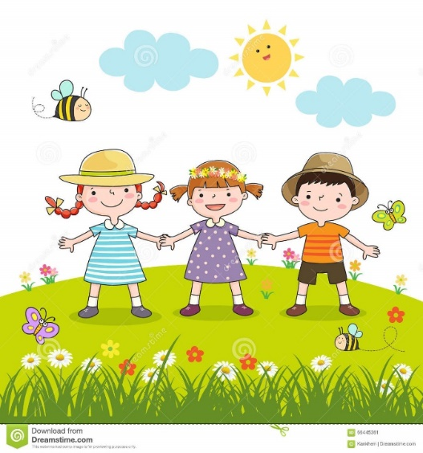 | 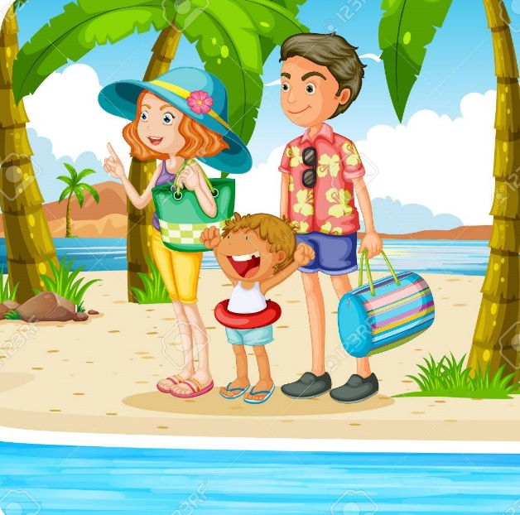  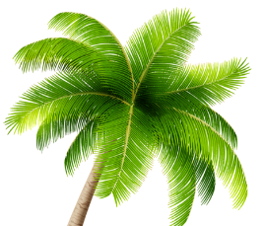  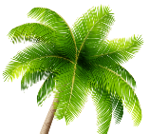

- TEACHER / STUDENT

What’s your favourite season? What clothes do you like wearing in this season?

ANSWER KEY

- GROUP DISCUSSION

It’s autumn.  It’s cloudy and chilly.  The boy on the left is wearing a jacket, trousers, a jumper and trainers.  The boy on the right is wearing a jacket, trousers, a cap and shoes.  The girl is wearing a jacket, a skirt and boots. | It’s winter.  It’s snowy and freezing/very cold.  The girl on the left is wearing a coat, earmuffs, a scarf, gloves, trousers and boots.  The girl on the right is wearing a coat, a woolly hat, earmuffs, a scarf, gloves, trousers and boots.  The boy is wearing a coat, a woolly hat, trousers, gloves and boots.
It’s spring.  It’s sunny and warm.  The girls are wearing a dress, socks and shoes. One of them has a hat.  The boy is wearing a T-shirt, shorts, a hat, socks and shoes. | It’s summer.  It’s sunny and very hot.  The mother is wearing shorts, a T-shirt, a hat and sandals.  The father is wearing a shirt, shorts and trainers.  The boy is wearing a T-shirt, shorts and flip flops.

- TEACHER /STUDENT

My favourite season is…
I like wearing…

