Name: ____________________________ Surname: ____________________________ N^{ber}: ____ Grade/Class: _____
Assessment: _____________________________ | Date: ___________________________________________________
 | Teacher’s signature:  ___________________________ | Parent’s signature:  ___________________________

Who is who?
Pair work – Each student choose one person and ask questions to guess who his/her partner is.

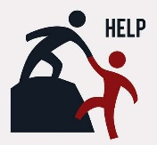
- Are you a boy or a girl?
- What are you wearing?
- What colour is / are your…?
- Are you wearing… ?
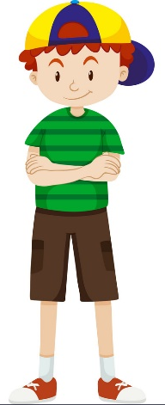

Ted | Nick | Paul | Mike | Peter | Jason | Tony

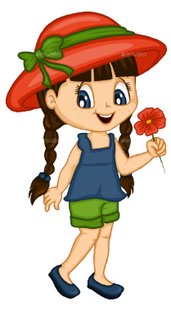

Vicky | Kate | Nancy | Helen | Mary | Jane | Anne

Name: ____________________________ Surname: ____________________________ N^{ber}: ____ Grade/Class: _____
Assessment: _____________________________ | Date: ___________________________________________________
 | Teacher’s signature:  ___________________________ | Parent’s signature:  ___________________________

ANSWER KEY

QUESTIONS | ANSWERS
Are you a boy or a girl? | I’m a … boy/girl.
What are you wearing? | I’m wearing:  - A jumper  - A t-shirt  - A shirt  - A blouse  - A jacket  - Trousers  - Shorts  - A skirt  - A dress  - A hat  - A cap  - Trainers  - Shoes  - Sandals  - Boots
What colour is your…  What colour are your… | It is… yellow, orange, blue, green, white  They are… pink, purple, red, grey, black, brown
Are you wearing a hat/a cap? | Yes, I am. / No, I’m not.
Are you Ted? | Yes, I am. / No, I’m not

