Name: ____________________________ Surname: ____________________________ N^{ber}: ____ Grade/Class: _____
Assessment: _____________________________ | Date: ___________________________________________________
 | Teacher’s signature:  ___________________________ | Parent’s signature:  ___________________________

- What are they wearing?
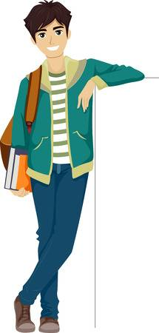
Mike Jennifer Andrew

- And you, what are they wearing today?

ANSWER KEY

1)
Mike is wearing a brown jumper, a blue shirt, green trousers and brown trainers.
Jennifer is wearing a green jumper, blue trousers and red trainers.
Andrew is wearing a green jacket, a white and green jumper, blue jeans and brown trainers.

2)
Today I’m wearing… an orange jumper, blue trousers and brown shoes.

