Name: ____________________________ Surname: ____________________________ N^{ber}: ____ Grade/Class: _____
Assessment: _____________________________ | Date: ___________________________________________________
 | Teacher’s signature:  ___________________________ | Parent’s signature:  ___________________________

Look at the picture.
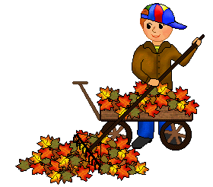
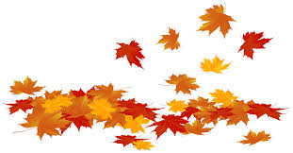
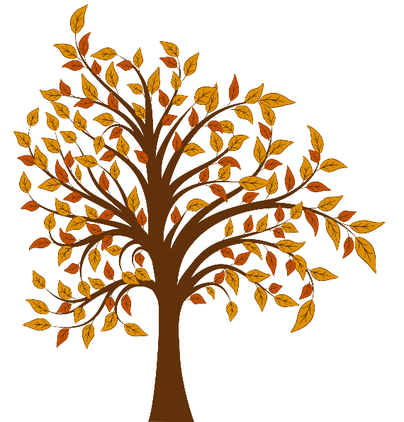
Answer the questions.

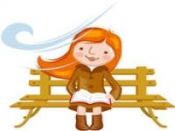

Jack

TEACHER’S QUESTIONS:

- What‘s the weather like?
- In your opinion, what season is it? Why? What can you see?
- What colour are autumn leaves?
- What is Jack doing?
- What is he wearing?
- And you? What are you wearing today?

ANSWER KEY

- It’s cloudy, windy and chilly.
- It’s autumn because leaves are falling down.
- Autumn leaves are yellow, orange, red and brown.
- Jack is flying a kite.
- He is wearing a blue jacket, a blue jumper, brown trousers and brown shoes.
- Today I’m wearing…

