Name: ____________________________ Surname: ____________________________ N^{ber}: ____ Grade/Class: _____
Assessment: _____________________________ | Date: ___________________________________________________
 | Teacher’s signature:  ___________________________ | Parent’s signature:  ___________________________

Imagine what they are wearing:

- Paul is going to run. What is he wearing?
- It’s sunny and warm, Mary’s going to the park. What is she wearing?
- It’s cloudy and mild, Jack’s going to school. What is he wearing?

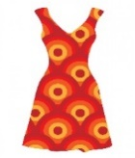
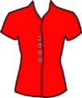
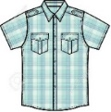
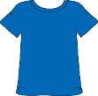

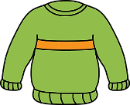
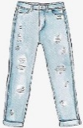

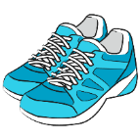
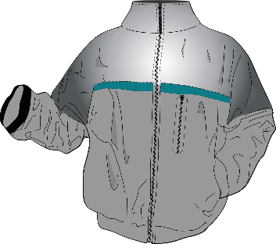

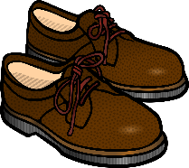

ANSWER KEY

Paul is wearing a green tracksuit and blue trainers.
Mary is wearing a red dress and pink sandals.
Jack is wearing a blue T-shirt, a grey jacket, blue trousers and brown shoes.

