Name: ____________________________ Surname: ____________________________ N^{ber}: ____ Grade/Class: _____
Assessment: _____________________________ | Date: ___________________________________________________
 | Teacher’s signature:  ___________________________ | Parent’s signature:  ___________________________
Find the 10 differences.
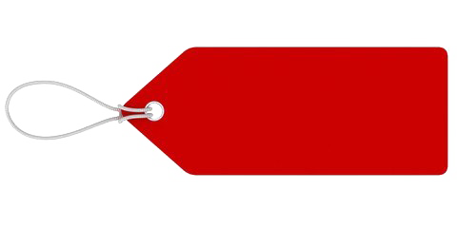
Jenny Bradley

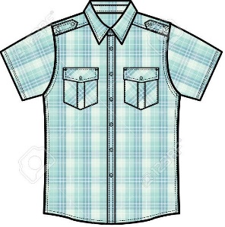
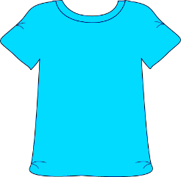
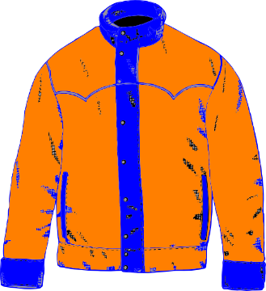
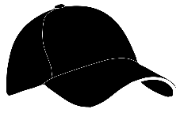
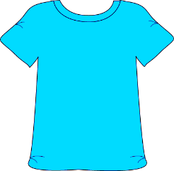
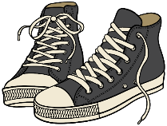
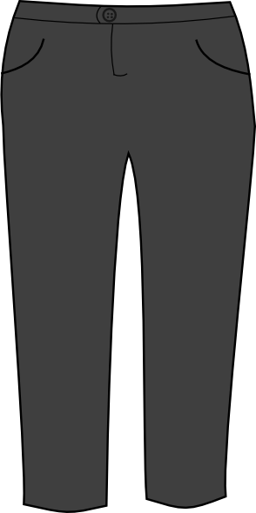

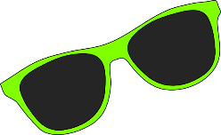
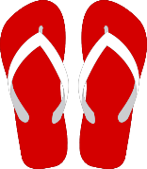
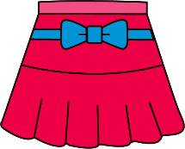

Name: ____________________________ Surname: ____________________________ N^{ber}: ____ Grade/Class: _____
Assessment: _____________________________ | Date: ___________________________________________________
 | Teacher’s signature:  ___________________________ | Parent’s signature:  ___________________________
Find the 10 differences.
Jane Bradley

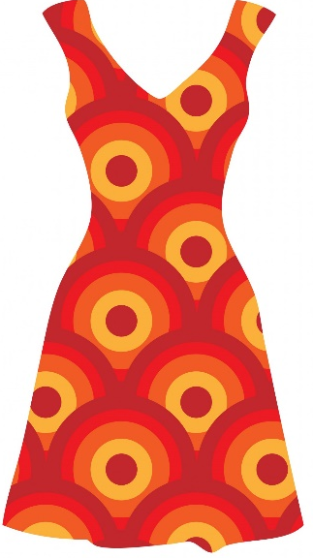
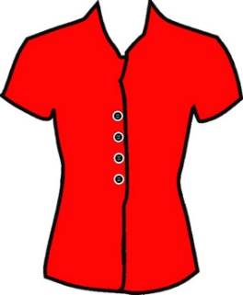
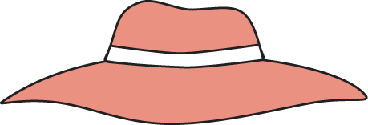

KEY ANSWER

 | PICTURE 1 | PICTURE 2
1 | It is Jenny Bradley’s suitcase. | It is Jane Bradley’s suitcase.
2 | There are 2 caps. | There is one hat.
3 | There are trainers. | There are sandals.
4 | The ball is white, yellow, blue and red. | The ball is yellow, green, blue and red.
5 | There are flip flops. | There is a swimsuit.
6 | There is a jacket and trousers. | There is a dress.
7 | One T-shirt is black. | One T-shirt is green.
8 | There is a shirt. | There is a blouse.
9 | The shorts are blue and green. | The shorts are blue and white.
10 | There are green sunglasses. | There are two red sunglasses.

