Name: ____________________________ Surname: ____________________________ N^{ber}: ____ Grade/Class: _____
Assessment: _____________________________  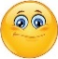 | Date: ___________________________________________________
 | Teacher’s signature:  ___________________________ | Parent’s signature:  ___________________________

Look at the picture.
Answer the questions.

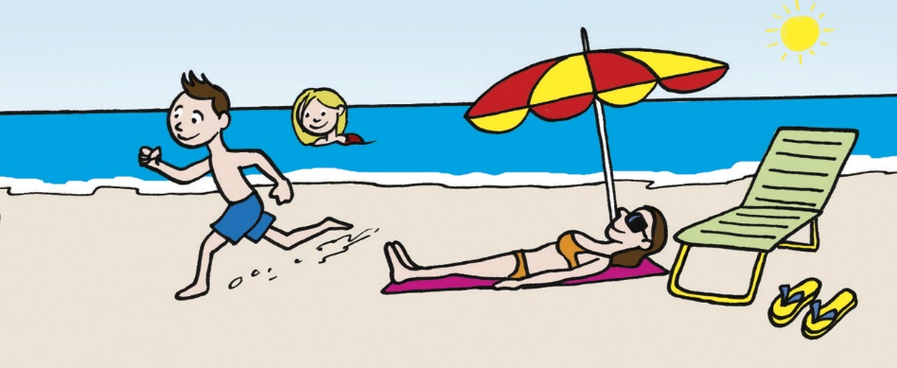

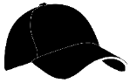

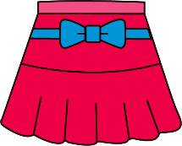
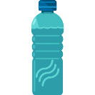

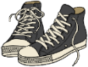

TEACHER’S QUESTIONS:

- What season is it?
- What‘s the weather like?
- What is on the chair?
- Where are the flip flops?
- What is the boy wearing?
- What is the woman wearing?
- And the girl?
- What clothes do you like wearing in summer?

ANSWER KEY
- It is summer.
- It’s sunny and very hot.
- There are sunglasses on the chair.
- The flip flops are near the chair.
- The boy is wearing blue shorts and a brown cap.
- The woman is wearing a pink dress.
- The girl is wearing a swimsuit and a pink hat.
- In summer I like wearing…

