Name: ____________________________ Surname: ____________________________ N^{ber}: ____ Grade/Class: _____
Assessment: _____________________________ | Date: ___________________________________________________
 | Teacher’s signature:  ___________________________ | Parent’s signature:  ___________________________

STUDENT A
- Look and tell your partner what there is in your bag: “In my bag there is / are…”

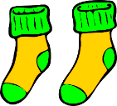
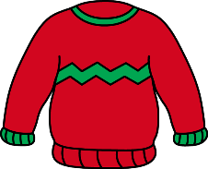
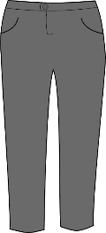

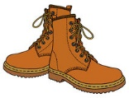
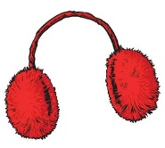

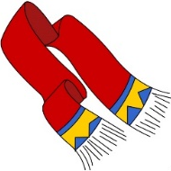
- Listen to your partner and link. There is an example.

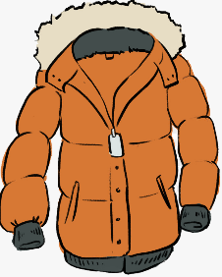
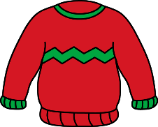
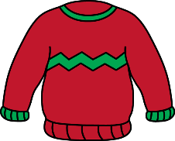

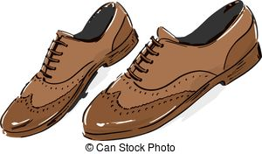

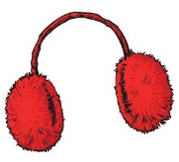
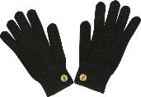

Name: ____________________________ Surname: ____________________________ N^{ber}: ____ Grade/Class: _____
Assessment: _____________________________ | Date: ___________________________________________________
 | Teacher’s signature:  ___________________________ | Parent’s signature:  ___________________________
STUDENT B
1) Listen to your partner and link. There is an example.

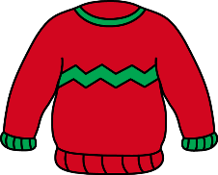

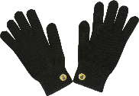

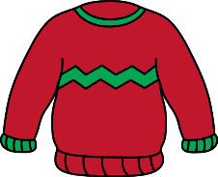
2) Look and tell your partner what there is in your bag: “In my bag there is / are…”

ANSWER KEY

STUDENT A:
In my bag there are two trousers, one jumper, socks, two woolly hats, earmuffs and boots.

STUDENT B:
In my bag there are trousers, two jumpers, one coat, boots, a scarf and gloves

