Name: ____________________________ Surname: ____________________________ N^{ber}: ____ Grade/Class: _____
Assessment: _____________________________ | Date: ___________________________________________________
 | Teacher’s signature:  ___________________________ | Parent’s signature:  ___________________________

Who is who?
Pair work – Each student choose one person and ask questions to guess who his/her partner is.

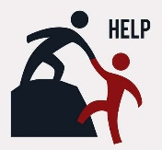
- Are you a boy or a girl?
- What are you wearing?
- What colour is / are your…?
- Are you wearing… ?

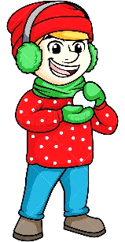
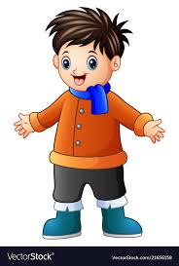
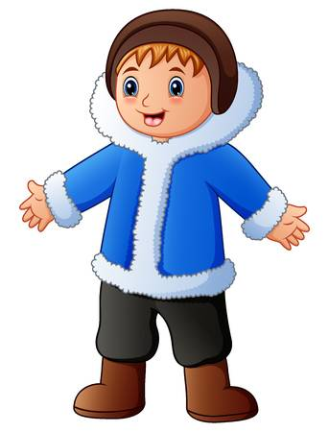

Tom Simon Robert Jack

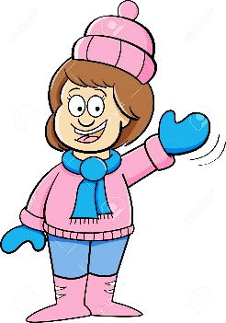
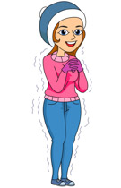
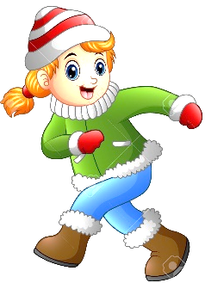
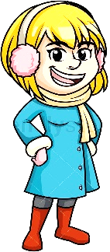

Daisy Sally Jenny Jane

ANSWER KEY

QUESTIONS | ANSWERS
Are you a boy or a girl? | I’m a … boy/girl.
What are you wearing? | I’m wearing:  - A jumper  - A coat  - Trousers  - A woolly hat  - A scarf  - Gloves  - Earmuffs  - Shoes  - Boots
What colour is your…  What colour are your… | It is… yellow, orange, blue, green, white  They are… pink, purple, red, grey, black, brown
Are you wearing earmuffs / gloves? | Yes, I am. / No, I’m not.
Are you Tom? | Yes, I am. / No, I’m not

