Name: ____________________________ Surname: ____________________________ N^{ber}: ____ Grade/Class: _____
Assessment: _____________________________ | Date: ___________________________________________________
 | Teacher’s signature:  ___________________________ | Parent’s signature:  ___________________________

Look and complete the crossword.
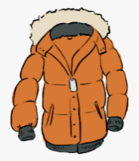
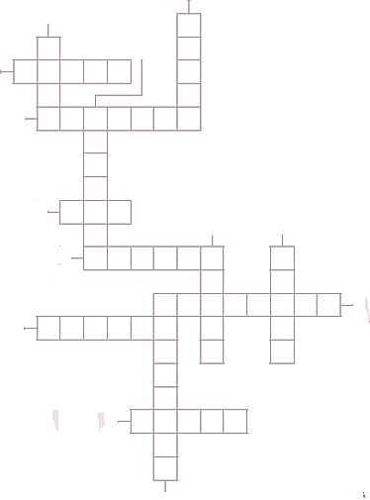
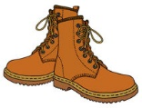
Ka
Sa
Oa
Ra
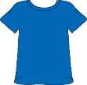
Ia
Sa
-a
Ta

Na
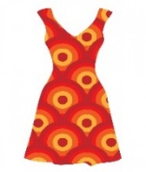
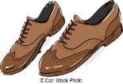
Aa

Da
Sa
Sa
Oa

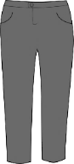
Ta
Ea
Oa
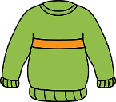
Ra
Ma
Ja
Sa
Ia
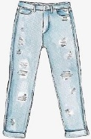
Ea
Na

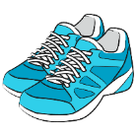

ANSWER KEY

Sa
Ca
Ka
Ia
Ta
Oa
Ba
Sa
Oa
Aa
Ra
R
Ha
Ta
Ia
Sa
-a
Ta
Aa
Na
Da
Pa
Ca
Aa
La
Ta
Ra
Ha
Da
Sa
Sa
Oa
Ha
Ra
Sa
Ua
Ra
Ra
Sa
Ta
Ea
Oa
Ea
Sa
Ea
Pa
Ua
Ra
Ma
Ja
Sa
Aa
Sa
Ia
Na
Ja
Sa
Aa
Ea
Na
Ra
Sa

