Name: ____________________________ Surname: ____________________________ N^{ber}: ____ Grade/Class: _____
Assessment: _____________________________  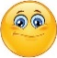 | Date: ___________________________________________________
 | Teacher’s signature:  ___________________________ | Parent’s signature:  ___________________________

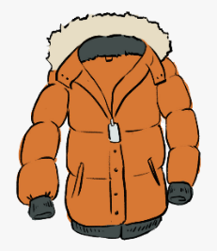
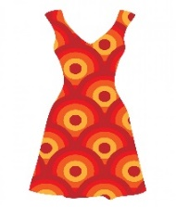
1) Label the pictures.
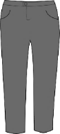
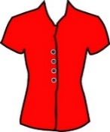
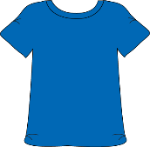

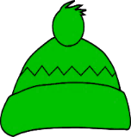
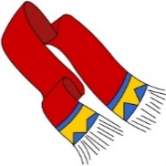
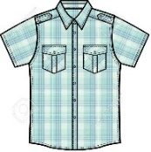
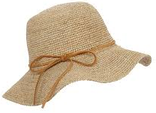
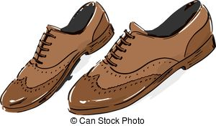

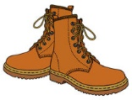
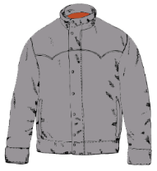
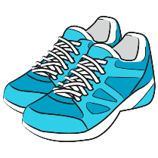
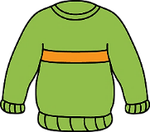
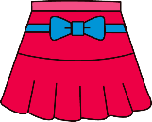

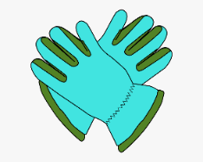
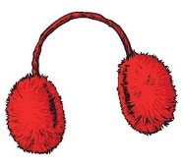
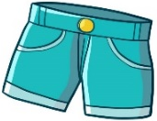
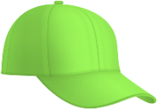

1. T-shirt 2. Trainers 3. Trousers 4. Cap 5. Coat 6. Hat 7. Shoes 8. Scarf
9. Skirt 10. Boots 11. Blouse 12. Jacket 13. Dress 14. Shirt 15. Earmuffs
16. Woolly hat 17. Jumper 18. Shorts 19. Gloves 20. Sandals

2) Write the words in the correct box.
___________________ ___________________
___________________ ___________________
___________________ ___________________
___________________ ___________________
___________________ ___________________

___________________ ___________________
___________________ ___________________
___________________ ___________________
___________________ ___________________
___________________ ___________________

Spring / Summer
Autumn / Winter

ANSWER KEY

EXERCISE 1

1 | 3 | 11 | 5 | 13
8 | 14 | 7 | 16 | 6
17 | 9 | 12 | 10 | 2
18 | 15 | 4 | 19 | 20

EXERCISE 2

Autumn / Winter | Spring / Summer
Trousers  Coat  Shoes  Scarf  Boots  Jacket  Earmuffs  Woolly hat  Jumper  Gloves | T-shirt  Trainers  Cap  Hat  Skirt  Blouse  Dress  Shirt  Shorts  Sandals

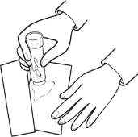
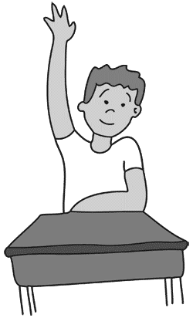
G E
U L

